**What is Terraform?**

Terraform is a tool for building, changing, and versioning infrastructure safely and efficiently. Terraform can manage existing and popular service providers as well as custom in-house solutions.

Configuration files describe to Terraform the components needed to run a single application or your entire datacentre. Terraform generates an execution plan describing what it will do to reach the desired state, and then executes it to build the described infrastructure. As the configuration changes, terraform is able to determine what changed and create incremental execution plans which can be applied.

Terraform is an [open-source](https://en.wikipedia.org/wiki/Open-source_software) [infrastructure as code](https://en.wikipedia.org/wiki/Infrastructure_as_code) software tool created by [HashiCorp](https://en.wikipedia.org/wiki/HashiCorp). It enables users to define and provision a datacentre infrastructure using a high-level configuration language known as Hashicorp Configuration Language (HCL), or optionally [JSON](https://en.wikipedia.org/wiki/JSON).[[3]](https://en.wikipedia.org/wiki/Terraform_(software)#cite_note-3) Terraform supports a number of cloud infrastructure providers such as [Amazon Web Services](https://en.wikipedia.org/wiki/Amazon_Web_Services), IBM Cloud (formerly [Bluemix](https://en.wikipedia.org/wiki/Bluemix)), [Google Cloud Platform](https://en.wikipedia.org/wiki/Google_Cloud_Platform), [Linode](https://en.wikipedia.org/wiki/Linode), [Microsoft Azure](https://en.wikipedia.org/wiki/Microsoft_Azure), [Oracle Cloud Infrastructure](https://en.wikipedia.org/wiki/Oracle_Cloud), [OVH](https://en.wikipedia.org/wiki/OVH) or [VMware vSphere](https://en.wikipedia.org/wiki/VMware_vSphere) as well as [OpenStack](https://en.wikipedia.org/wiki/OpenStack).

**Installation Process of Terraform in RHEL-Linux**

1. Create one practice VM and install RHEL – Linux
2. Create one directory or folder in root path

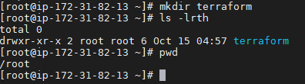

1. Download latest binaries in above path

Goto below path and select Linux 64 bit

<https://www.terraform.io/downloads.html>

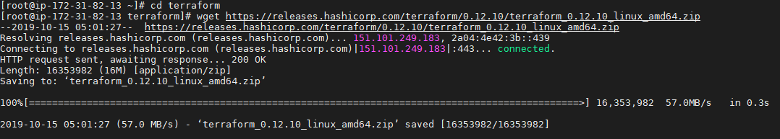

1. Check once whether it is downloaded or not.



1. Unzip the above binaries.



1. If unzip/wget is not work, please install unzip and wget using below command

Yum install unzip / yum install wget

1. Set the terraform path permanently

Go to home directory cd ~

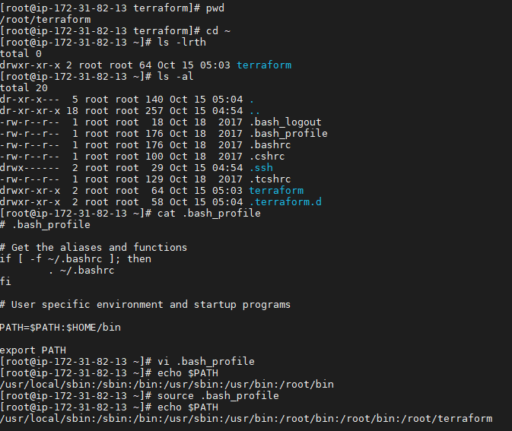

1. Check the terraform version using below command.



1. Create a .tf files in terraform home path /root/terraform below files.
2. Provider.tf



1. users.tf



1. rd.tf



1. s3.tf



1. lb.tf



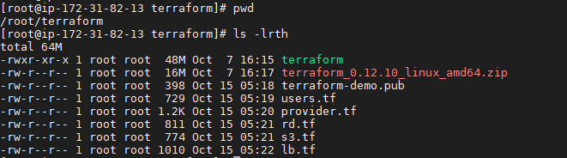

1. Before creating files copy user instance access_key, security_key and zone.

To find your Access Key and Secret Access Key:

1. [Log in to your AWS Management Console](http://aws.amazon.com/).
2. Click on your user name at the top right of the page.
3. Click on the Security Credentials link from the drop-down menu.
4. Find the Access Credentials section, and copy the latest Access Key ID.
5. Click on the Show link in the same row and copy the Secret Access Key.

**It’s time to execute code**

1: This will initialize the terraform working directory OR it will download plugins for a provider (example: aws)

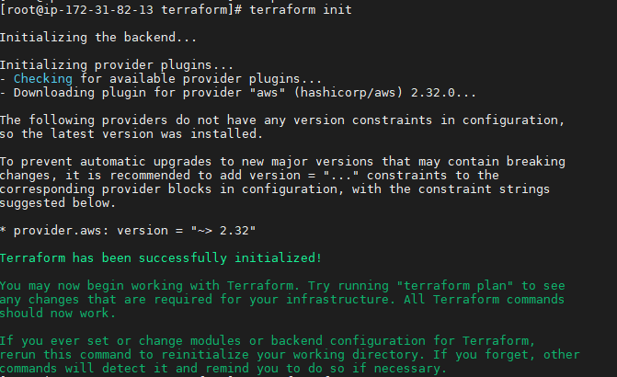

1. Enter below command in terraform home path terraform fmt it will arrange the code in orderly.



1. Enter the validate command it will validate our code if any errors it will through the errors.

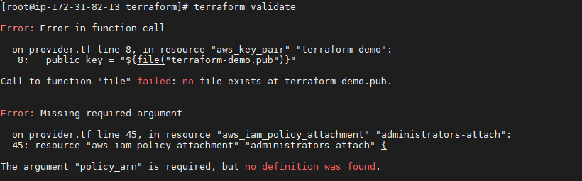

1. Create terraform-demo.pub file in terraform home path. using touch command.



1. Copy the ssh-key in above file.

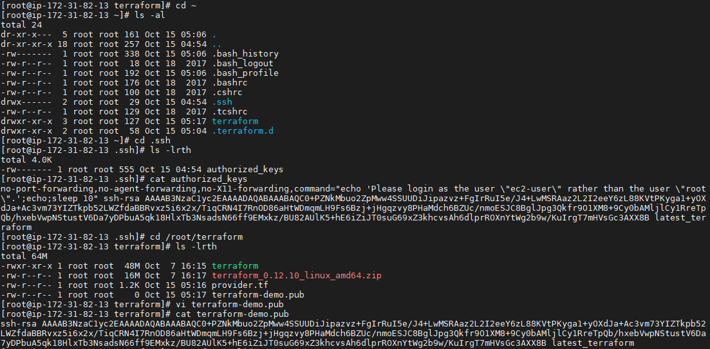

1. Enter validate command if any errors are there it will check.



1. Let you see what terraform will do before making the actual changes

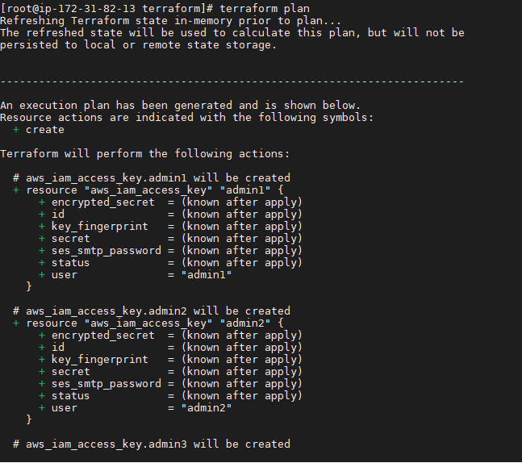

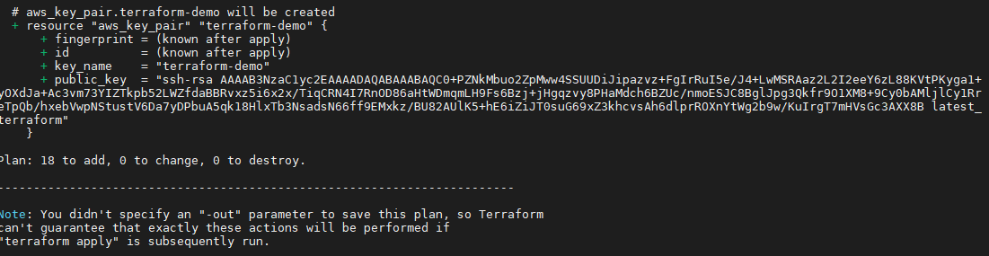

1. To, create the instance, we need to run terraform apply
2. Before entered terraform apply command check your dash board.

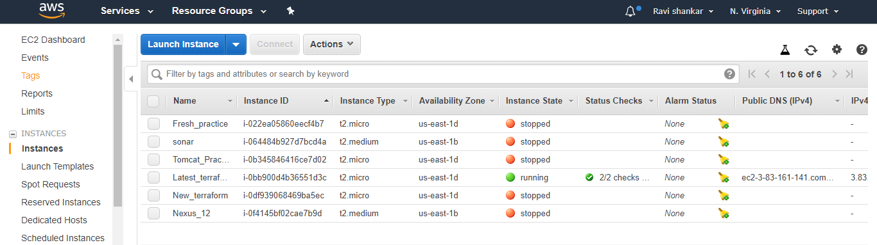

Next enter terraform apply command in cli.

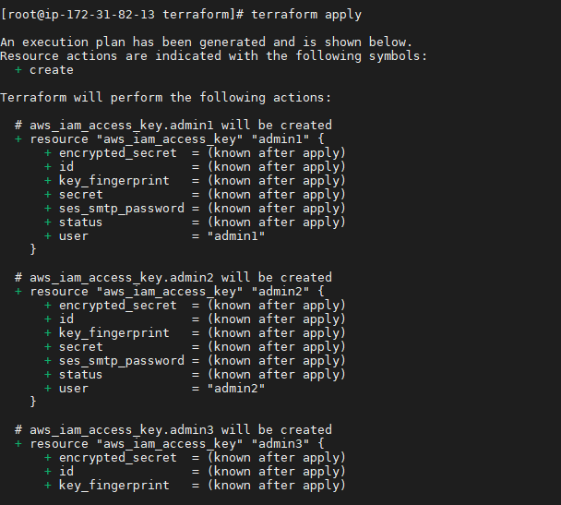

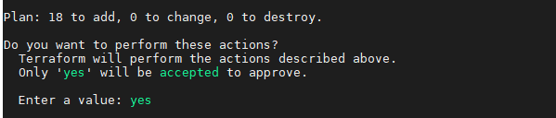

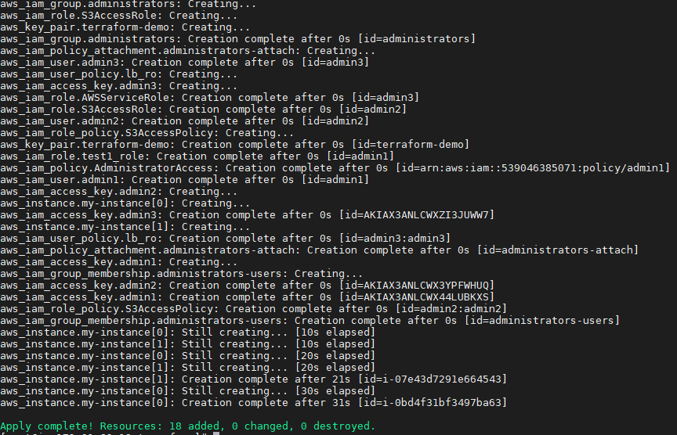

Finally, it comes Apply complete! Resources: 18 added, 0 changed, 0 destroyed.

Next check your Aws consul whether it is created or not. Refresh your consul and check.

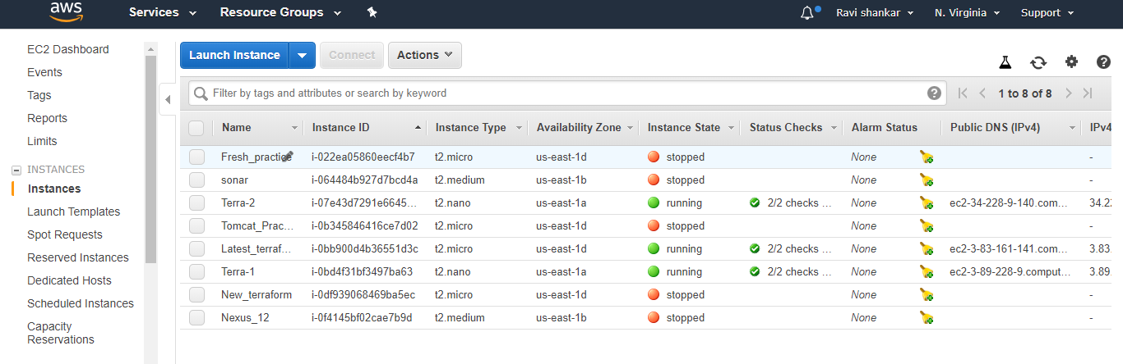

*Check once users are created or not*

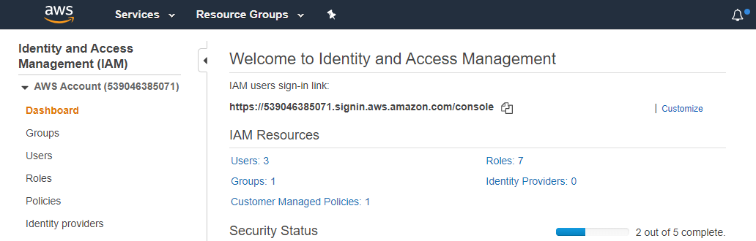

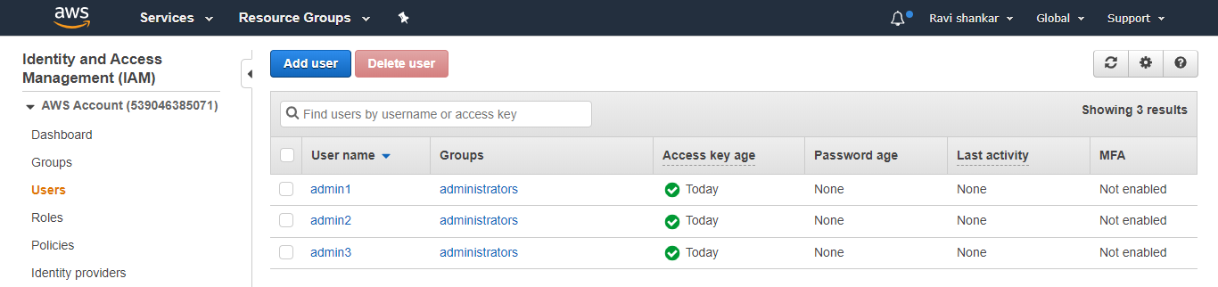

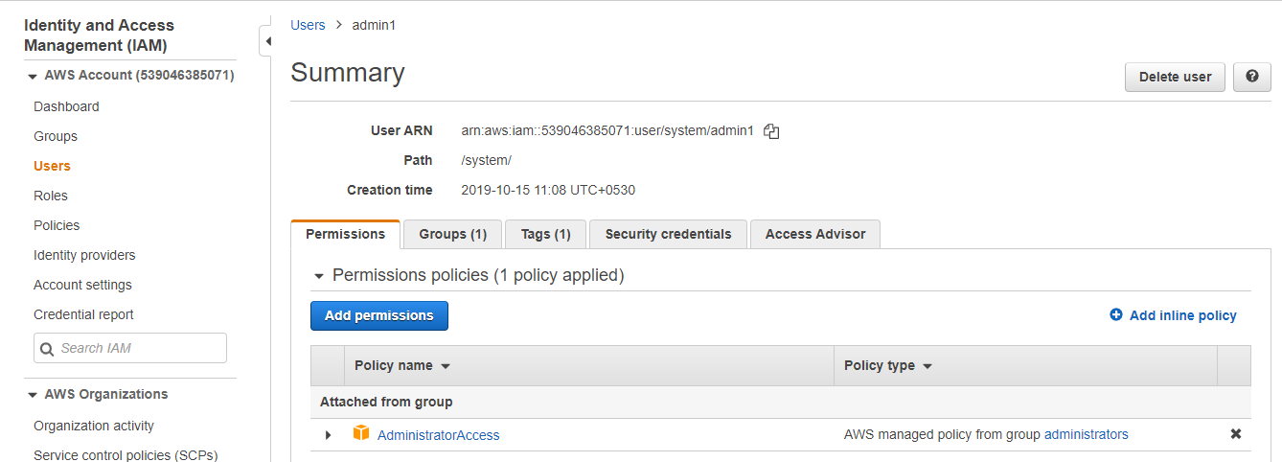

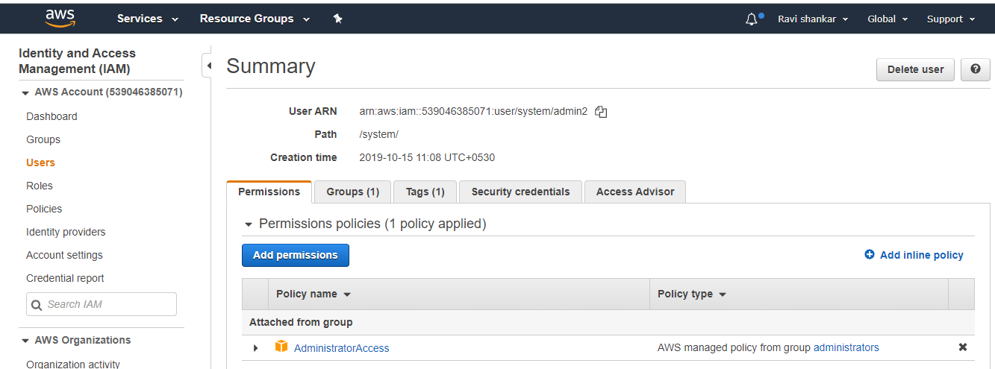

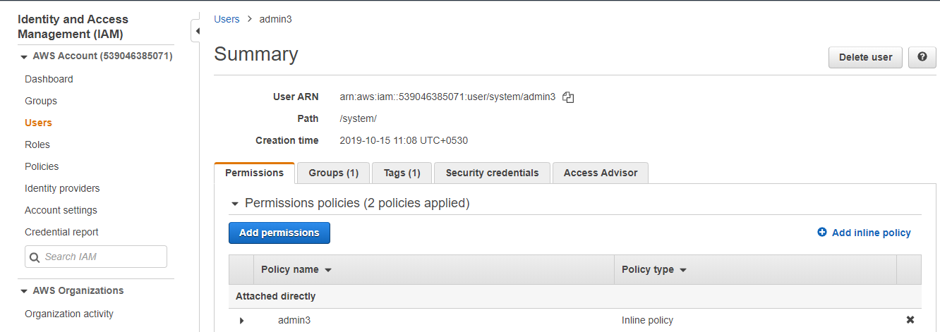

*Check once group created or not*

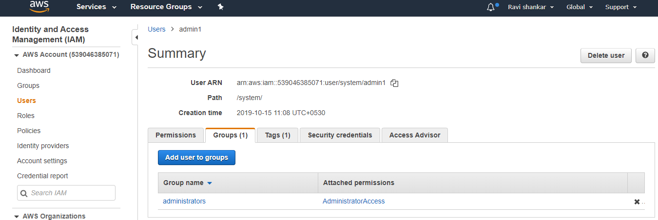

*And tag also*

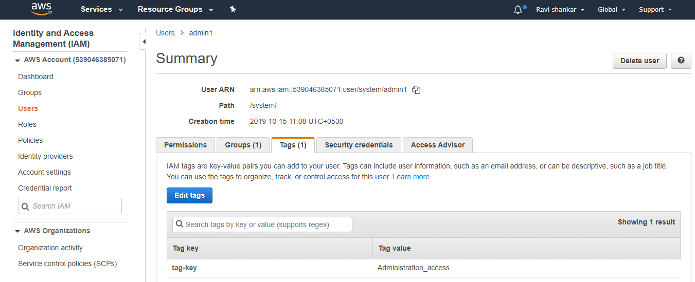

How to destroy the created instances and users?

Using below command we can destroy

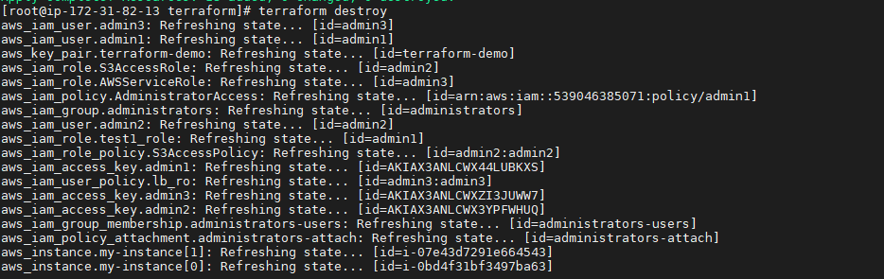

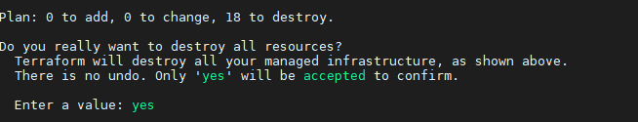

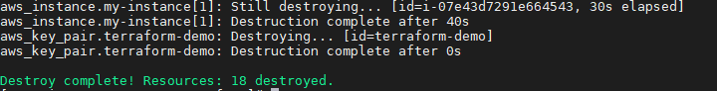

*Check once in your AWS consul refresh your consul and check whether it is it destroy or not.*

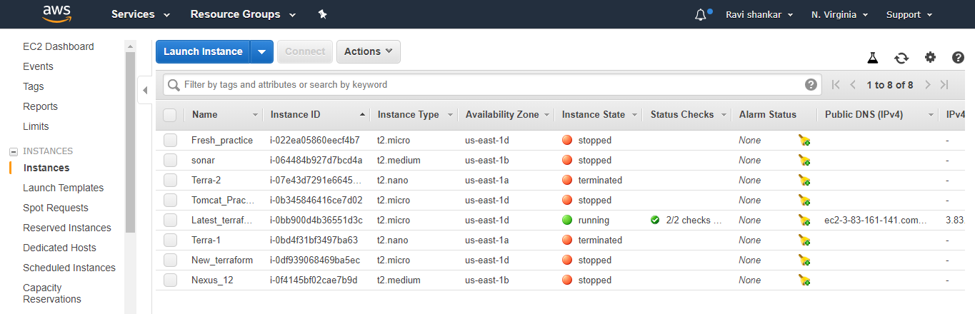

##############################THE END####################################